ImageJ: Finding the area of an object

In order to work with some of the data we get from the plants, we’re going to use a program called ImageJ. ImageJ is a completely free program that works on Windows, Mac OS, Mac OS X, Linux and even some PDAs. Basically, what we’re going to do today is download ImageJ, take some pictures of simple shapes with the cameras, and get the area of the shapes using ImageJ.

- First of all, go to this website: http://rsb.info.nih.gov/ij/download.html to download the program. ImageJ is a free program created by the research branch of NIH (the National Institutes of Health), so you can install it on any computer you’d like, at home or at school.
  - For Windows PCs, download the program bundled with Java 1.3.1_13 and run the file (http://rsb.info.nih.gov/ij/download/win32/ij136-setup.exe). It should install and place an entry in your Start menu.
  - For Mac OS X, download the program for OS X and double click the downloaded file (http://rsb.info.nih.gov/ij/download/osx/ij136.tar.gz). It should extract a folder called ImageJ (OS X) containing the program.

- We’re done installing software, so we can start with the fun stuff. Just to prove that the area calculator of ImageJ works, we’re going to take a picture of an object with a known area, and see if ImageJ agrees with us. You can use any shape, but I would recommend something simple. I used a right triangle. Cut the shape out of black construction paper. To make things simple, no edge of the figure should be over 7 inches.

- Calculate the area of your paper figure so we can test ImageJ. For example, I used an isosceles right triangle made from the corner of a sheet of construction paper with a base of 5 and a height of 5. So the area of my triangle (one half base times height) is 0.5*5*5, or 12.5. We’ll see if ImageJ agrees.

- Once you have your shape and your area, photograph it! One of the most important things to know is that ImageJ requires a ruler or some other object of known length in the picture to understand the scale. Place your object on a white piece of paper along with a ruler. Try to take the picture as perpendicular to the paper as possible to have the most accurate scale. Take a couple shots from different angles and with different framing to insure that you get a good shot.

- The next step is to transfer the images from the camera to the computer. ImageJ can use any image format so just make sure you select a place to save the pictures that is easy to find.

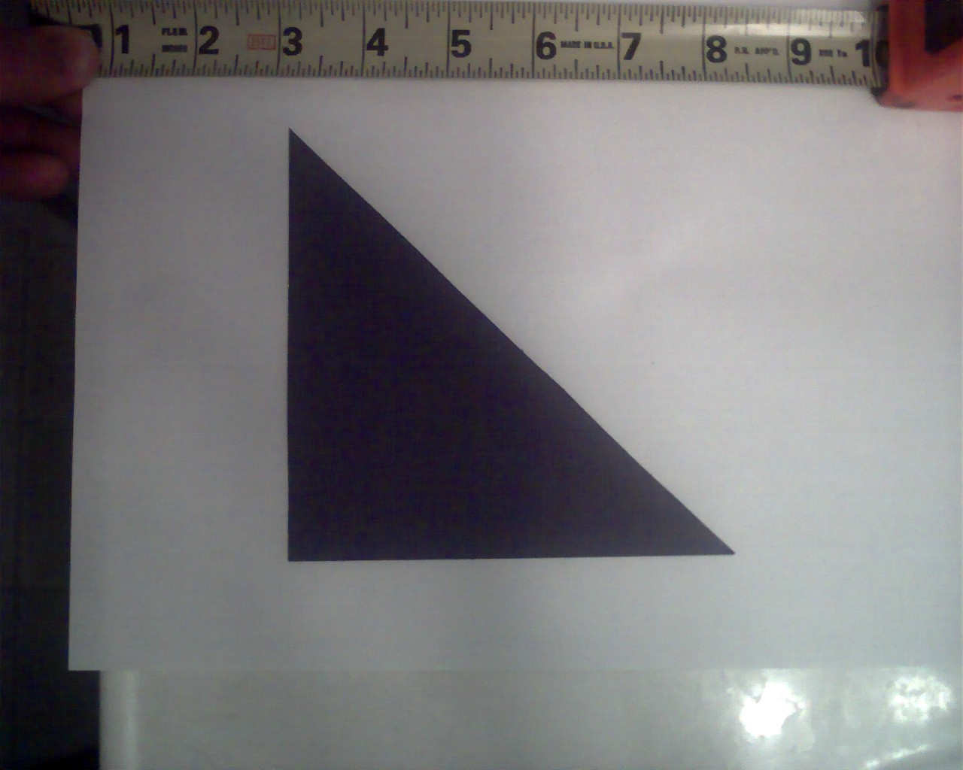
- The pictures should now be saved on the computer. Browse through the pictures and find the best picture, insuring that the entire shape is in the picture as well at least a few inches of the ruler. If your pictures are all poor, try taking some more. Digital pictures are free. Don’t worry about excess stuff around the edges; we’ll get rid of that later.

- Now open the ImageJ application. Using the File Menu, open the best picture you’ve taken. 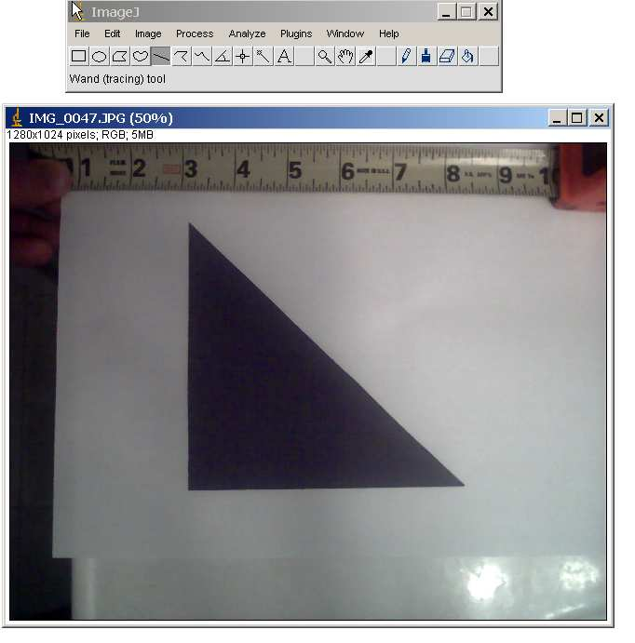
- The first thing we’re going to do is set the scale. To do this, click on the Straight line selections tool (the straight line button, fifth from the left). Trace along your ruler for a few inches then select Set Scale under the Analyze menu. Then put in the distance in the Known Distance field, and the unit in the Unit of Length field. From now on, it will display distances you measure in inches as well as pixels.
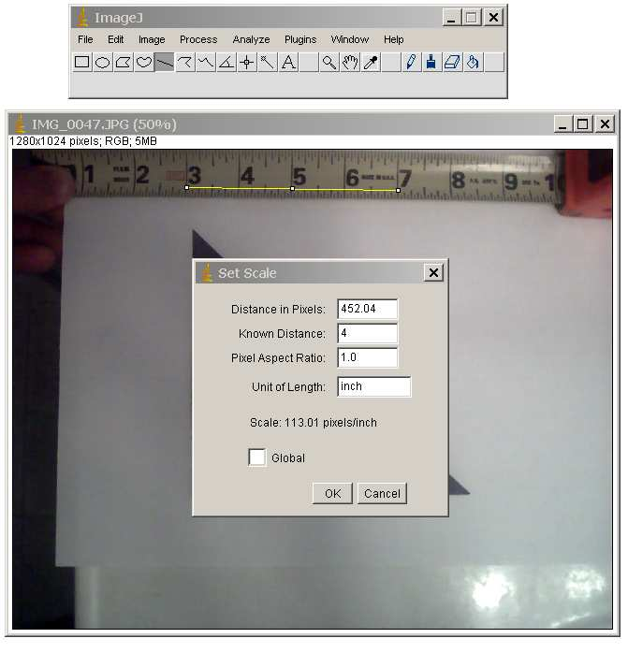

- Next, we have to tell the computer what is part of the shape and what is not. The computer recognizes the shape by its color. The greater the contrast between the shape and the background, the better. First of all, we need to make it a black and white image. To do this, go to the Image menu, and under Type, select 8-bit. 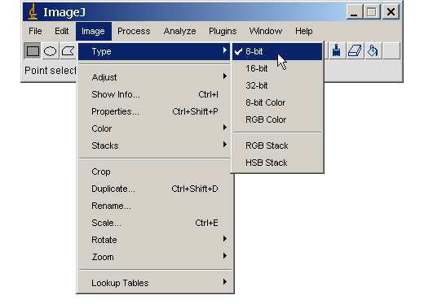

- After your image has been made black and white, tell ImageJ what is shape and what is not shape. To do this go to the Image menu, select Adjust and then select Threshold. The parts that the computer is selecting as your shape are displayed in red on your image. Move the top slider all the way to the left. Move the bottom slider around till your entire shape is red and none of the immediately surrounding background is red. Don’t worry about the ruler or the edges of the picture, just the immediate vicinity of your shape. It’s ok to move the little windows out of the way. After you’re done, there’s no need to click any of the buttons at the bottom. Just close the threshold window.

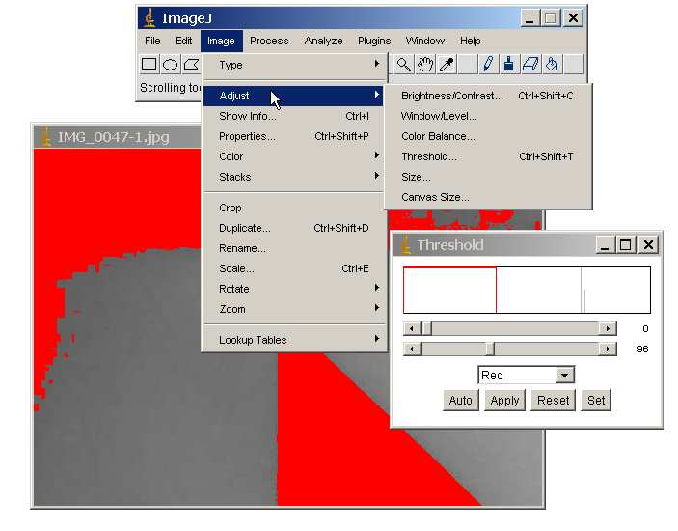

- Now that ImageJ knows the scale of your image and knows what your shape is, you’re ready to find the area! Select the image by clicking on the Rectangular selections tool on the ImageJ bar (the leftmost picture of a rectangle). Draw a box around your shape. Be careful not to get any red pieces inside your box that are not your shape. Now go to the Analyze menu and click Set Measurements. Make sure the Area and the Limit to Threshold boxes are checked. This tells ImageJ to get the area of the red shape and just the red shape. The other boxes will take other measurements. The Min and Max Gray Value box will measure the minimum and maximum darkness of the selection. The mean box will show the mean darkness. None of these options matters for the calculation of area, so you can uncheck these.
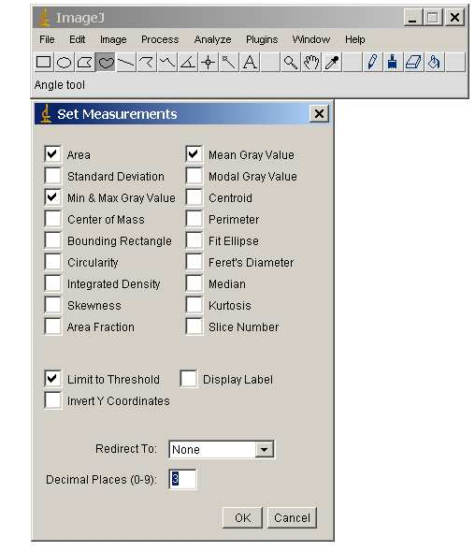

- Then go to the Analyze menu again and select Measure. This gets the area. 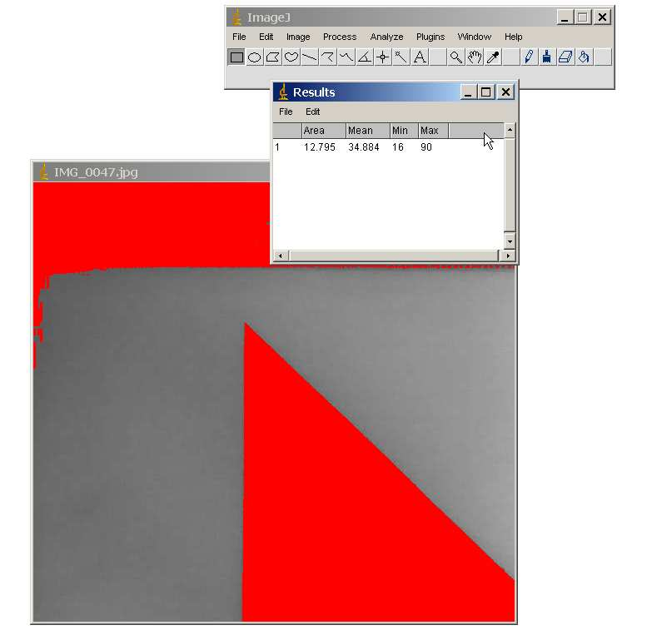

The measured area of my shape was 12.795, as opposed to the 12.5 from my calculations. I measured my shape with a ruler when I was done, and sure enough, my edges that were supposed to be 5 inches were slightly above that. Another source of error could be a mistake while setting the scale, or the quality of the cameras.

- Another activity to try is to measure the area of Lake Michigan. To do this, I simply went to Google Maps (http://maps.google.com), navigated to Lake Michigan, got a picture of it with the scale, and roughly cleaned it up in Adobe Photoshop. If you’re interested in learning how to do this, I can do a demonstration. For now, I’ve posted the picture here: http://www.mste.uiuc.edu/projects/aims/folders/staff/msidarous/imagej/lake.jpg

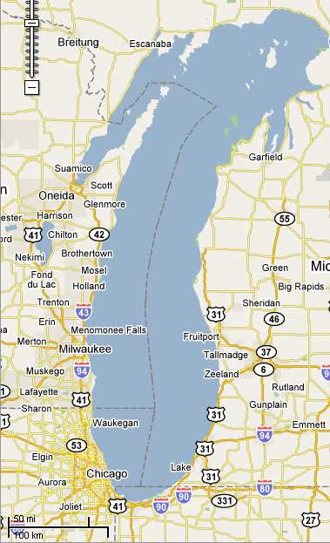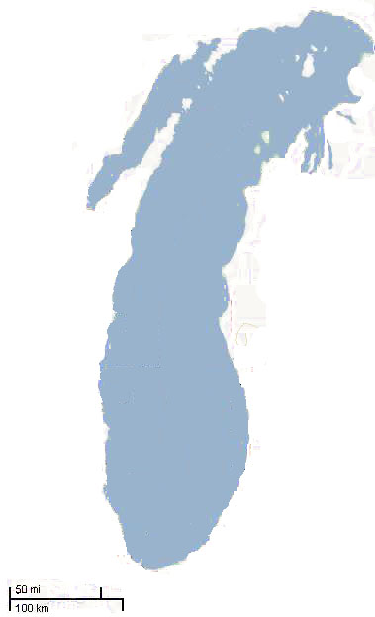

- Once you have the image, open it in the ImageJ application. As we did with the triangle, set the scale. To do this, click on the Straight line selections tool (the straight line button, fifth from the left). Trace along your ruler for a few inches then select Set Scale under the Analyze menu. Then put in the distance in the Known Distance field, and the unit in the Unit of Length field. From now on, it will display distances you measure in inches as well as pixels. Also, make it a black and white image. To do this, go to the Image menu, and under Type, select 8-bit.

- After your image has been made black and white, tell ImageJ what is lake and what is not. To do this go to the Image menu, select Adjust and then select Threshold. The parts that the computer is selecting as your shape are displayed in red on your image. Move the top slider all the way to the left. Move the bottom slider around until the lake is red and none of the immediately surrounding background is red. Close the Threshold window

- Select the lake by clicking on the Rectangular selections tool on the ImageJ bar (the leftmost picture of a rectangle). Draw a box around Lake Michigan. Now go to the Analyze menu and click Set Measurements. Area and the Limit to Threshold boxes should still be checked, but you should verify this.

- Go to the Analyze menu again and select Measure. This gets the area of Lake Michigan. Verify the measured area against the known area on Wikipedia (http://en.wikipedia.org/wiki/Lake_Michigan).

